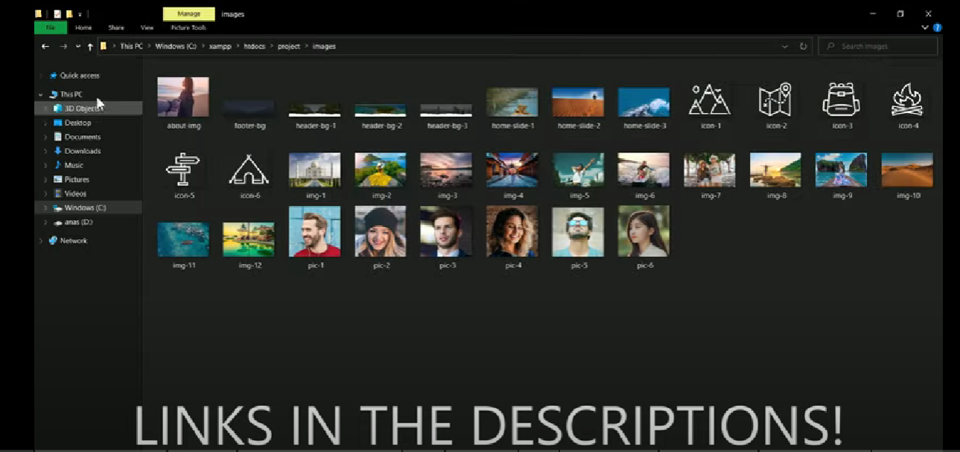

12 destination/place images

6 person/model images happy

Mountain icon

Map icon

Bag icon

Campfire icon

Direction board icon

Tent icon

Picture for home slide dessert/pool/girl with hat

Header images \*\*\*\*\*

Girls holding hand back image